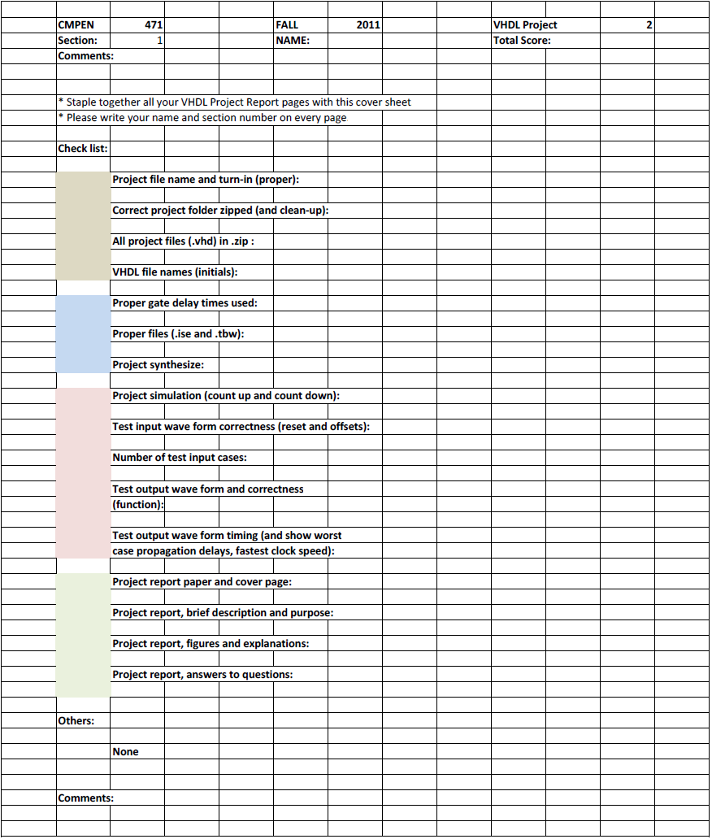
Erik Arfvidson
4

Erik Arfvidson
10/11/2012
Lab4

Project Report4

Simulations
I was unable to create a testbenchfile with the name specified since I had some issues with windows file rewriting to a previously erasen file. So the name for my Test bench file name is eee. I apologize for the improper naming convention. But given that time was a circumstance I was unable to explore the root of the issue. I also want to mention that this occurred when I started a new project so I had to fall back to the one that was working to demonstrate the output

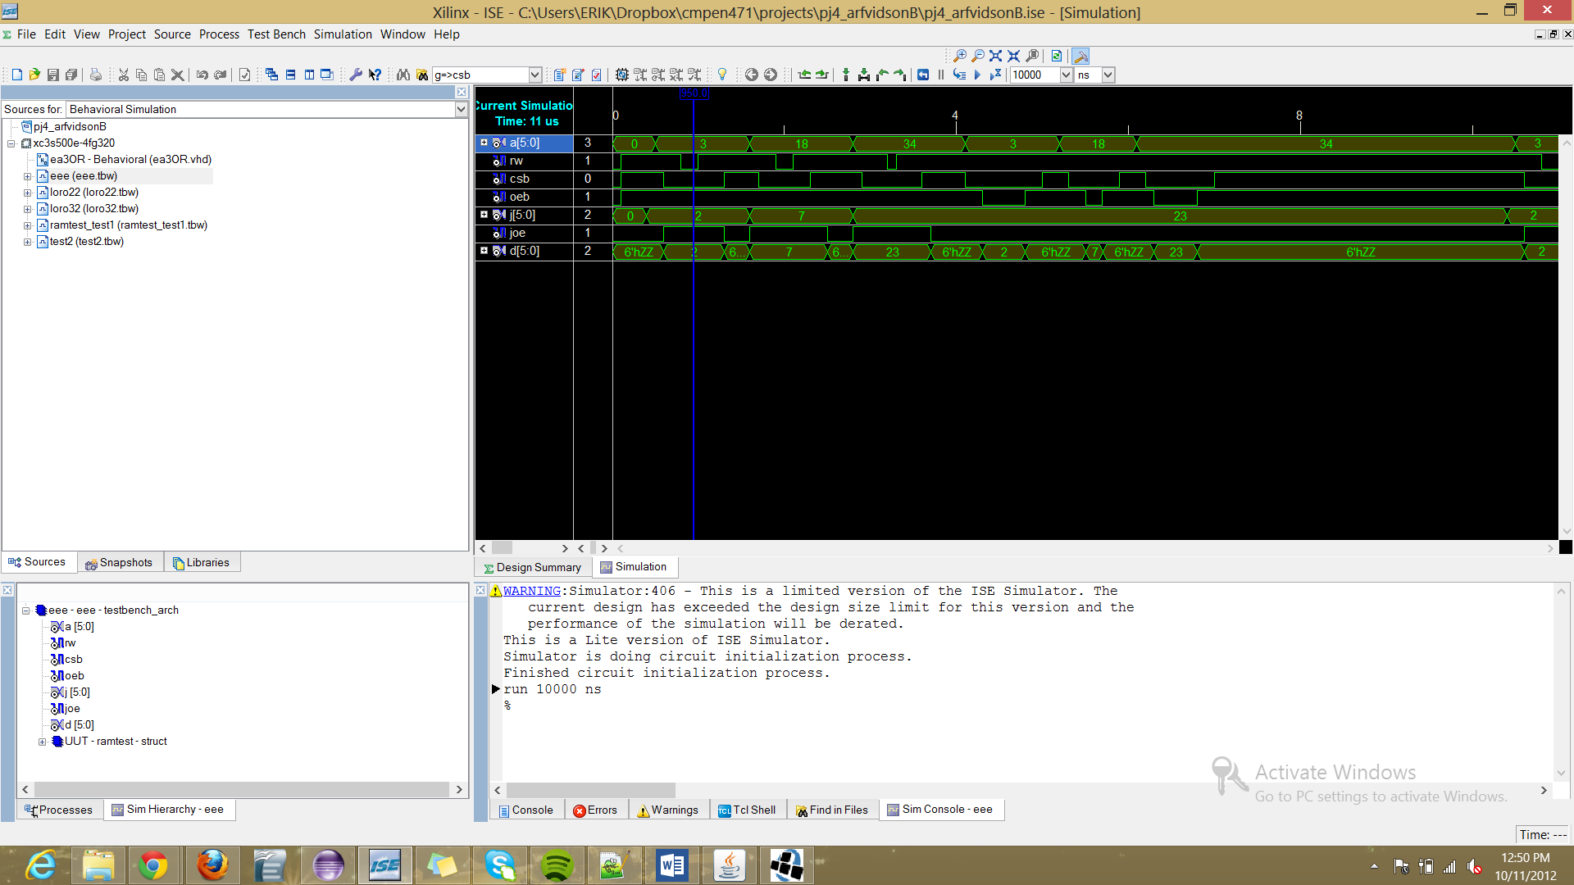
The pin description of my 64 bit RAM and my RAM TESTER
PIN DESCRIPTION
SYMBOL | Description
A(5 downto 0) | Address input Selector
RW | Read or Write Selector
CSB | Enable or Disable
OEB | Output Enable
J | Data input(Write in data)
JOE | Data input enable
D | Data Input and Output result

The truth table of my Ram And RAM tester

TRUTH TABLE
JOE | CSB | RW | OEB | MODE | D
X | H | X | X | NOT SELECTED | High Z
X | L | H | H | Output Disable | High Z
L | L | H | H | Read | Data Out
H | L | L | L | Write | Data IN
The read Cycle and of my ram timings
Read Cycle
Parameter | Min | Max
Read Cycle Time | 713ps | x
Address Access Time | x | 350ps
Chip Select Access Time | x | 160ps
Output Enable to Output Valid | x | 720ps
Chip Selection to Out low Z | 160ps | x
Output Enable to out low Z | 150ps | x
Chip Deselection to Out in High Z | X | 430ps
Output Disable to output in High Z | X | 435ps
Output hold from address change | 430ps | x
The write Cycle and of my ram timings

Write Cycle
Parameter | Min | Max
Write Cycle Time | 320ps | x
Chip Selection to end of write | 935ps | x
Address valid to end of Write | 330ps | x
Address Setup Time | 0ps | x
Write Pulse Width | 350ps | x
Write Recovery Time | 0ps | x
Data valid to end of write | 150ps | x
Data hold from end of write | 140ps | x
Write To Output in High Z | X | 0ps
Output disable to output in high Z | X | 0ps
Output Active from end of write | 120ps | x

